## INTRODUCTION

In order to optimize a multivariable quadratic function that may or may not be linearly limited, one technique is known as quadratic programming. A quadratic program may be used to represent a variety of real-world issues, including cost reduction for manufacturers and portfolio optimization for businesses. The enlarged simplex algorithm, for example, can be used to solve a viable solution if the objective function is convex. Some non-convex quadratic functions can be solved using methods, but they are difficult to use and not widely available.

In quadratic programming, an objective function is minimized using mathematical optimization techniques. Numerous choice factors, some of which could or might not be constrained, make up the objective function. The power of the choice variables is either 0, 1, or 2. Numerous linear equality and inequality restrictions about the choice factors may be applied to the objective function.

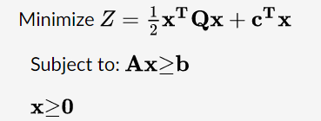

## PROBLEM STATEMENT

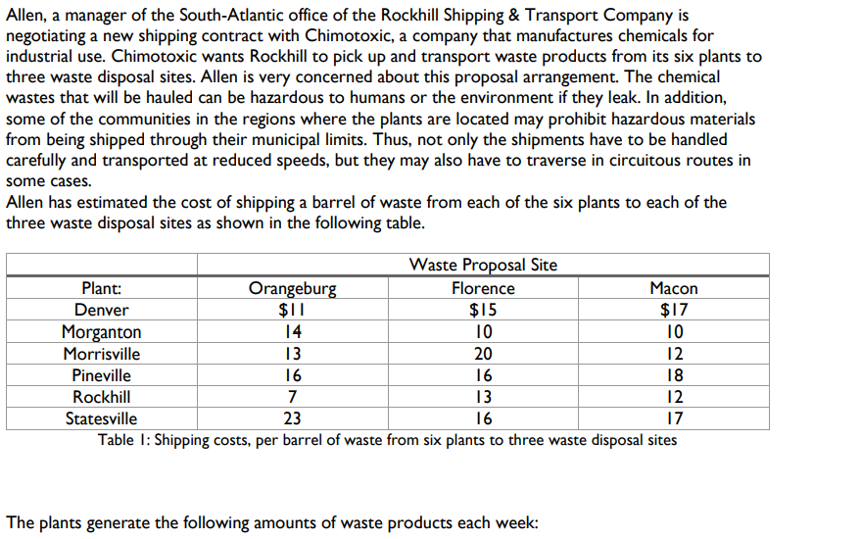

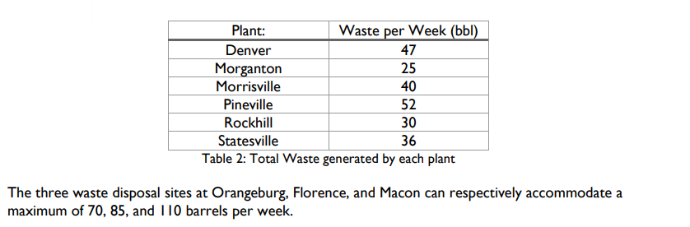

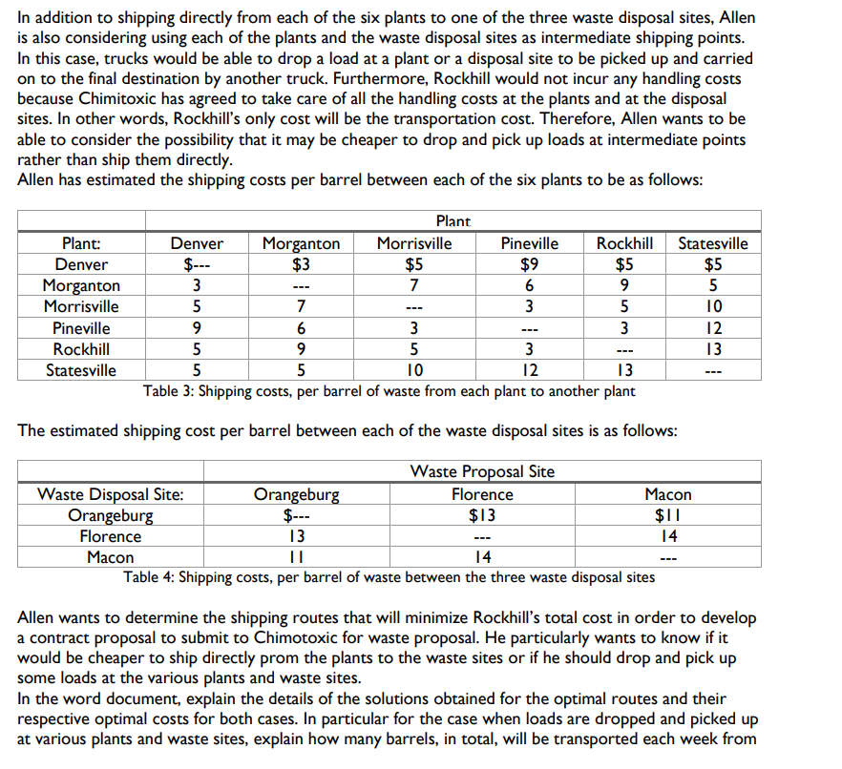

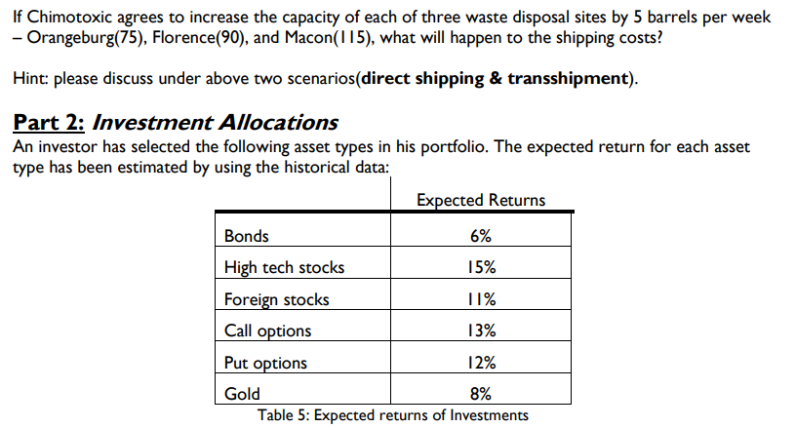

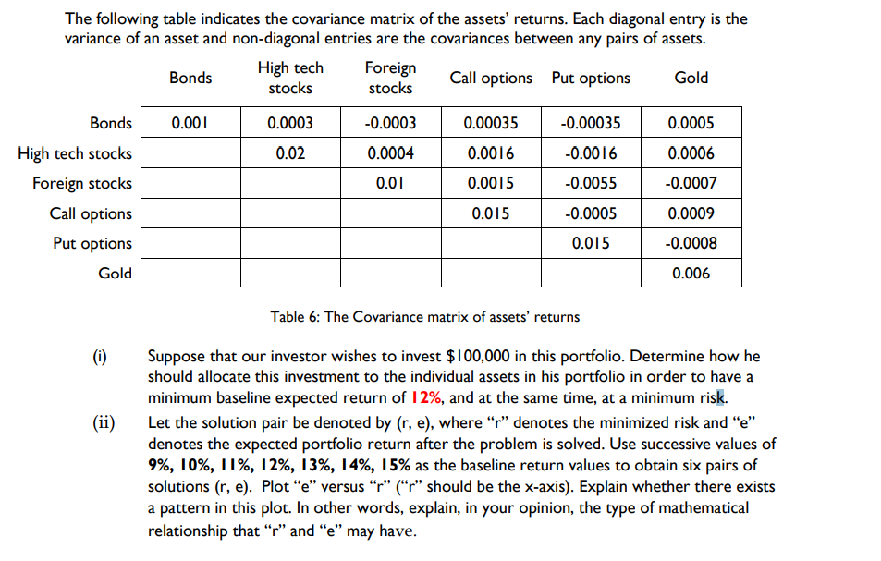

## ANALYSIS

## PART ONE

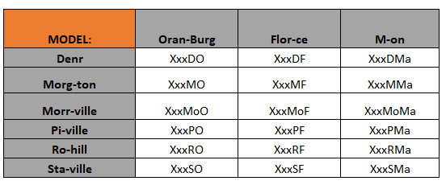

Using the specified trash proposal side and the transportation costs of each barrel from each plant site. Based on their intended course, we could build a model. These are the factors that will determine the best course of action, and the results will be based on that.

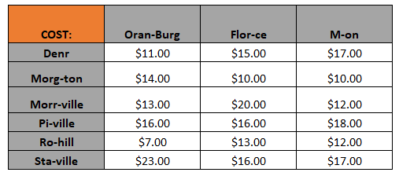

Then, we took the destination path model we created and populated it with the data supplied to use for calculating the cost of each barrel's transportation.

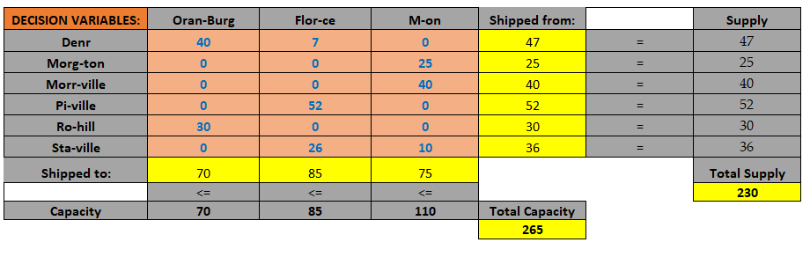

Finally, we developed an optimized destination route using the Excel Solver that we can apply to the transportation of each barrel. We placed this model under three constraints. The first is each trash proposal site's capacity (Orangeburg, Florence, and Macon), which was denoted in the previous line by capacity. The second restriction concerned the supply and waste generated by each plant site, which is shown on the right side under Supply. The non-negativity restriction for each choice variable came last.

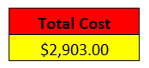

The final minimized total cost came out to be $2,903, which is the optimal price of shipping.

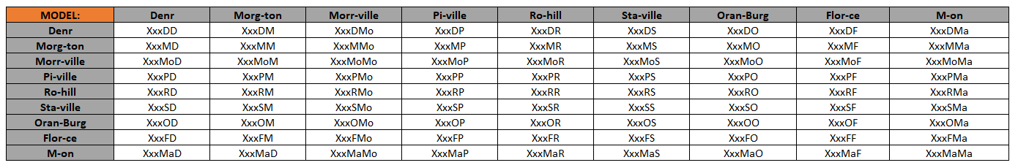

Each industrial and waste disposal facility is now used as an intermediary shipment point. Then, while creating a model, we must incorporate all the sites. Consequently, a model was developed with the waste disposal facilities included.

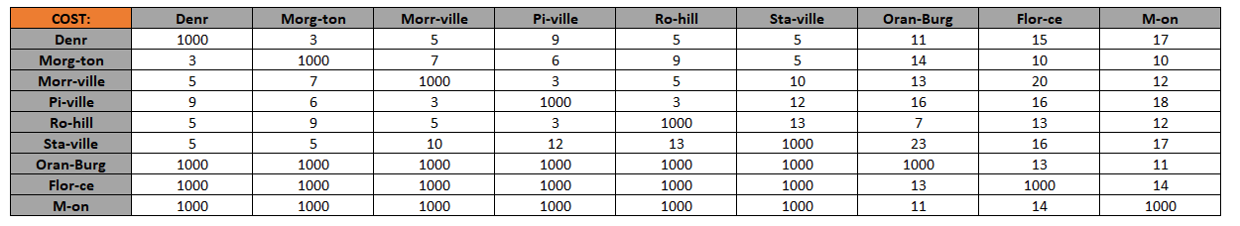

Then, we used the data provided to populate the destination path model we had constructed in order to determine the cost of shipping each barrel. For information that wasn't supplied to us or for similar situations, such as Denver - Denver, we entered 1000 since arbitrary high values would prevent those situations from being selected by the Solver.

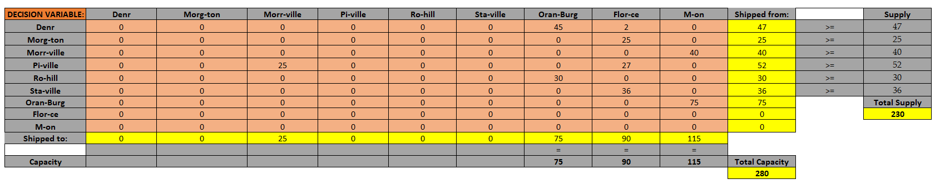

Finally, we used the Excel Solver to create an optimum destination route that we could use to carry each barrel, but this time, each plant's capacity had been raised by 5, so the routes were 75, 90, and 115. We applied three restrictions to the model. The first is that each suggested site's capacity should match its own. Second, the value of the shipment should be more than or equal to the value of the supply. Non-negative Constraint was the final one.



The ultimate total cost that was reduced came out to be $3,373, which is the best rate for shipping between each location and was more expensive than direct shipment. Thus, direct shipment is suggested.

## PART TWO

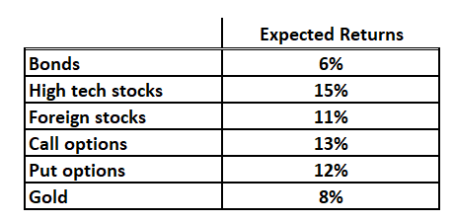

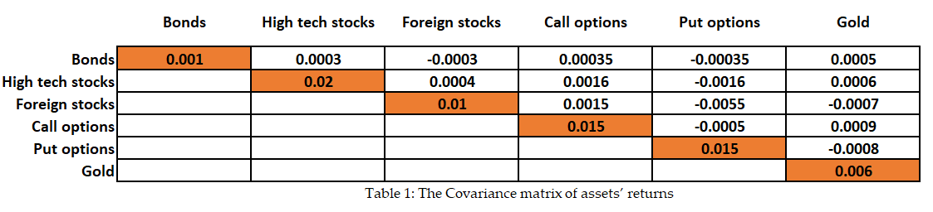

The returns indicated are present in the investor's portfolio. We will build a portfolio using the provided table and the specified covariance matrices for each asset.

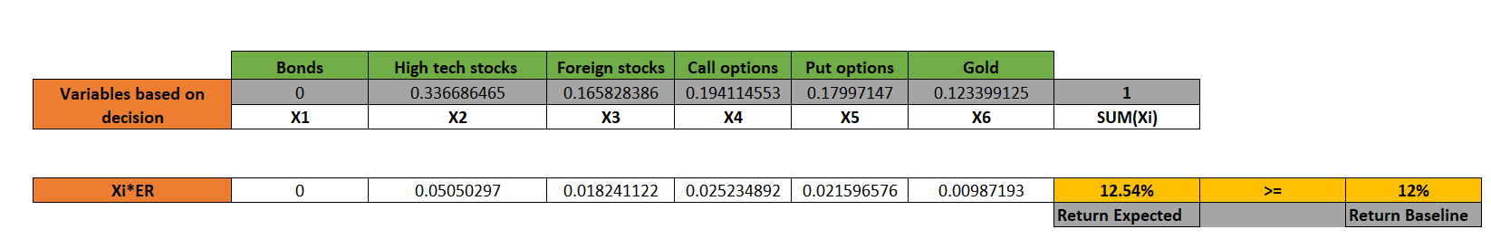

The portfolio was then developed using the Solver to show how we should invest in each stock to reduce risk and anticipate returns of up to 12 percent or higher. Here, we can see that the solver provided the best result, with an estimated return of 12.54 percent. The requirements that we utilized were that the predicted return be higher than 12 percent and that the overall portfolio balance should equal 1, which indicates that all of the money has been invested. Using these numbers, we can build an allocation table where we invested $100,000 throughout the whole portfolio.

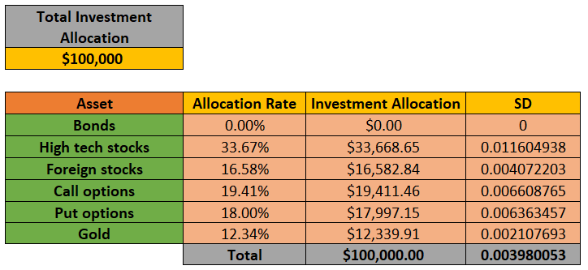

The values we obtained from the solver were multiplied by the $100,000 investment allocation supplied after we utilized them as allocation rates. Using that, we calculated the investment allocation amount and added it to the overall investment allocation value to ensure accuracy. Then, using the covariance matrices for each allocation rate, we estimated the standard deviation of each allocation rate, and using the total of all the values and the expected return, we calculated the risk for a return of 12.54 percent, or 0.003980053.

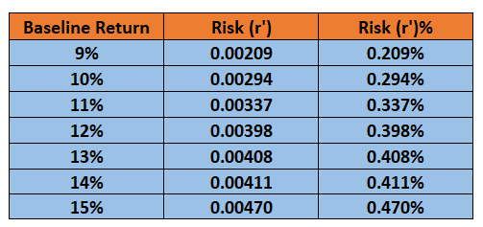

We estimated the risk for 9 percent, 10 percent, 11 percent, 12 percent, 13 percent, 14 percent, and 15 percent using the same method we used to evaluate the risk associated with the projected return of 12 percent. To calculate the risk values, we utilized Solver for each and followed the same procedure for each baseline return percent.

The predicted return (baseline return) to the risk (in percent) value was depicted using a scatterplot. We can see that there is a trend between these factors. These graphs lead us to the conclusion that when we increase the minimal base rate of return for the particular portfolio, we must reduce the risks that go along with it. Therefore, I believe there needs to be a proper balance between risk and projected return percentage. The mentioned chart also includes the general trendline.

## CONCLUSION

Finally, while working on this report, I learnt about binary programming and quadratic programming. For binary programming, I worked on real-world direct transport and transshipment data, and I learned about quadratic programming while working on an investment portfolio. I also learnt about the notion of least squares programming, where the outcome of the optimized solver was compared with expected values. In order to develop models based on the transportation and investment systems in the future, I understood how they operate now. I gained knowledge about the covariance matrix, how to apply it to stock allocation, how risk interacts with anticipated return, and how to employ several shares of stocks to maximize profits.

## BIBLIOGRAPHY

1) What is Quadratic Programming? (2022, May 26). D. Poupon. https://www.wise-geek.com/what-is-quadratic-programming.htm

2) Barik, S. K. (2012, March 7). Probabilistic Quadratic Programming Problems with Some Fuzzy Parameters. Hindawi. https://www.hindawi.com/journals/aor/2012/635282/

3) Quadratic programming - optimization. (2015). Jack Heider. https://optimization.mccormick.northwestern.edu/index.php/Quadratic_programming

4) Purchasing and Inventory Optimization Examples. (2020, March 5). Solver. https://www.solver.com/purchasing-and-inventory-optimization-examples